English IGCSE students study First Language English (0500) & World Literature (0408) IGCSEs in Year 10 and 11
There will be regular practice exam opportunities throughout the 2 years of study.
Final examinations for both FLE & WL IGCSEs take place in May/ June in Year 11.

First Language English IGCSE (0500)
PAPER 1 - Reading Paper Exam - 50%  Q1 - Reading Comprehension  Q2 - Summary Writing & Inference  Q3 - Authorial Intentions  Q4 - Text Types Transposition | Skills  - Information Retrieval  - Inference & Deduction  - Explicit and Implicit Information  - Authors’ Craft  - Paraphrasing and Summary Writing  - Evaluation & Persuasion  - Composition Writing  - Creative Writing
PAPER 2 - Writing Paper Exam - 50%
Q1 - Directed Writing - Evaluation and Persuasion
Q2 - Composition Writing - Descriptive/ Narrative
World Literature IGCSE (0408)
The Importance of Reading
The best way to ensure success in English Language and Literature is to regularly read quality fiction and non-fiction, including newspapers and articles. The earlier this becomes a habit, the better.
Academic Integrity and Coursework Honesty Policy:
They will read and sign an IGCSE Academic Honesty agreement at the start of their coursework - this includes abiding by the strict expectations about AI use, plagiarism, the role of the tutor and being the sole author of all of their work
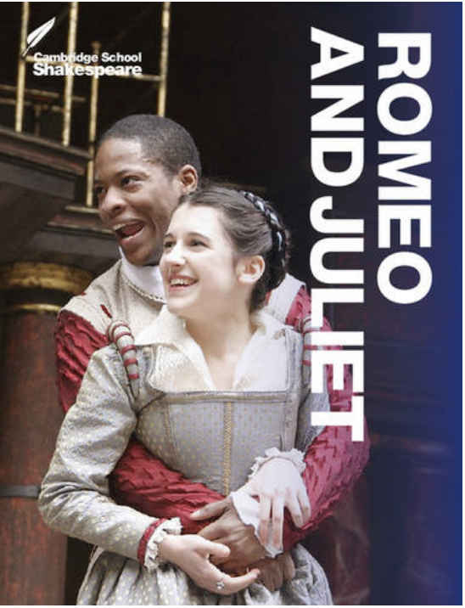  COMPONENT 1 - Coursework: Drama Text- approx. 33%  Required Text: Romeo & Juliet by William Shakespeare  by Cambridge University Press ISBN: 9781107615403  Empathic Writing (approx. 800 words)  Critical Essay (approx. 1000 words) | Skills  - Imaginative writing from different perspectives  - Empathic response  - Genre Conventions  - Poetic techniques  - Narrative techniques  - Dramatic techniques  - Literary Analysis  - Annotation  - Character and Theme Study  - Social and Historical Context  - Essay Structure  - Thesis Statements  - Crafting Effective Arguments  - Writers’ Intentions  - Impact/Effect on the Reader
PAPER 2 - Poetry - approx. 33%
Text: 15 poems from Songs of Ourselves Vol 3 Poetry
Q1 - Set Text Poem Essay (poem provided)
Q2 - Unseen Poem Essay (poem provided)
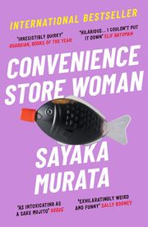
PAPER 3 - Set Text Novel - approx 33%
Text: Convenience Store Woman by Sayaka Murata
Essay response to TWO questions on the novel.
Q1 - Provided Extract Essay
Q2 - Closed Book Essay

